NRC+PICKER
Combining the advanced measurement and improvement technology
of National Research Corporation with the philosophies
and family of surveys of The Picker Institute®.

Control Charts

Training Guide

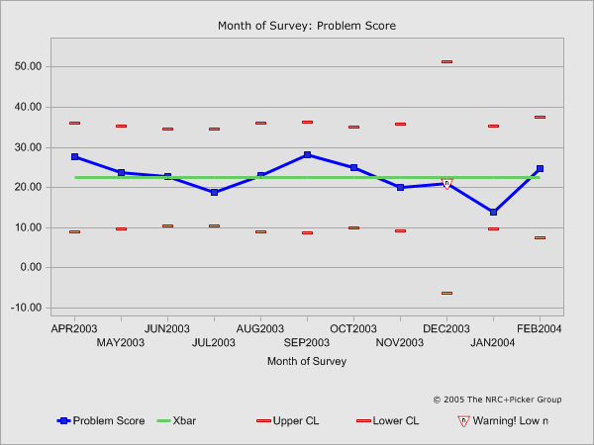

Table of Contents

Introduction 3
About this Tutorial 3
Module 1 3
Module 2 3
Module 3 3
Training Sessions and Additional Support 3
Brief Primer on Control Charts 4
Module 1 – Control Chart Features 4
Xbar-S Control Chart Features 5
Specific Features of the SChart 6
Specific Features of the Xbar Chart 6
Additional Features and Information 7
p - Control Chart Features 7
Specific Features of the p-Chart 8
Additional Features and Information 8
Module 2 – Accessing Control Charts 9
Logging On 9
Creating Your “My Solutions” Bookmark 10
Signing On To Your eReports 10
Click on the icon that says “eReports”. 10
The eReports Menu 12
eToolKit view My Data 14
Module 3 – Basic SPC Techniques and Control Chart Formulas 18
Utilizing SPC Techniques to Understand Control Charts 18
Assessing Special Cause Variation 18
Formulas for Calculating Xbar-S Charts and p-Charts 19
Control limit for Percent score 19
Control limit for mean score 19
Recommended Formulas for the XBar and s Charts: 20

Introduction

NRC+Picker is excited to bring you the latest innovation in patient experience tracking and reporting.

NRC+Picker is pleased to provide to their clients control charts. Relying on sound Statistical Process Control (SPC) techniques NRC+Picker has developed control charts to display percent response (problem and positive score) information and mean score information.

These new features are available by accessing eReports and by accessing eToolkit (if you are a current subscriber).

About this Tutorial

This tutorial presents what you need to know to use control charts. The tutorial is divided into three parts:

Module 1
Demonstrates how to interpret control charts and defines the features present within the charts.

Module 2
Provides basic information about accessing the control chart through our web based reporting tools.

Module 3
Covers the basic elements of SPC techniques and the formulas used to calculate the control charts.

Training Sessions and Additional Support

NRC+Picker will provide clients with special training sessions. Sessions will cover the content of each module within the tutorial. These sessions provide an opportunity for questions and answers addressing specific needs with a NRC+Picker expert.

Your NRC+Picker Improvement Team and Area Manager are always available by email or phone to assist you. Questions can be directed to these associates by calling 1-800-388-4264.

Brief Primer on Control Charts

A control chart is a graph that provides a pictorial representation of data in which special cause variation is distinguished from common cause variation. Common cause variation is something that is inherent in the system or process being studied. In contrast, special cause variation occurs when there is a deviation from the standard process. This type of variation can be positive or negative and tends to be introduced into the system. Therefore, when special cause variation is present the system is said to be unstable. In order to make process improvement a success one must first establish stability within the system or process before seeking improvement opportunities.

Control charts allow the user to measure and understand variation within data by separating variation that occurs naturally (common cause) from specific variation that is introduced into the system (special cause). By using mean scores to measure data, the control chart is sensitive to changes due to special cause variation. Mean scores, unlike median or mode scores are sensitive to extreme variations or outliers. A control chart utilizes the mean trend line as the centerline of the chart and utilizes upper and lower control limits that reflect the variation as measured by standard deviation around the observed mean scores. Upper and lower control limits are typically calculated to be + 3 standard deviations.

Under the Central Limit Theorem that states that while the population distribution may not be normally distributed the resulting distribution of averages from sample observations will be normally distributed around the average value. Because the sample observations will be normally distributed setting the upper and lower control limits at + 3 standard deviations ensures that 99.73 percent of the values will be contained within three standard deviations of that average value.

When an observed value falls outside of the upper or lower control limits the Central Limit Theorem and normal distribution parameters indicates that only .27 percent of all observed values should fall within this region. Therefore, because this rare event is highly unlikely to occur by chance alone (common cause variation) the process is said to be unstable and due to special cause variation.

Module 1 – Control Chart Features

After completing Module 1 of the tutorial, you should feel comfortable:

- Interpreting the features of the Control Chart for mean scores and percent response scores (problem and positive scores)

NRC utilizes an Xbar-S Chart for mean score Control Charts. When viewing percent response data a p-chart is used. This tutorial will first cover the features associated with the Xbar-S Chart and then discuss the p-chart.

Xbar-S Control Chart Features

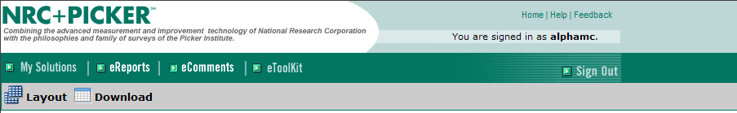
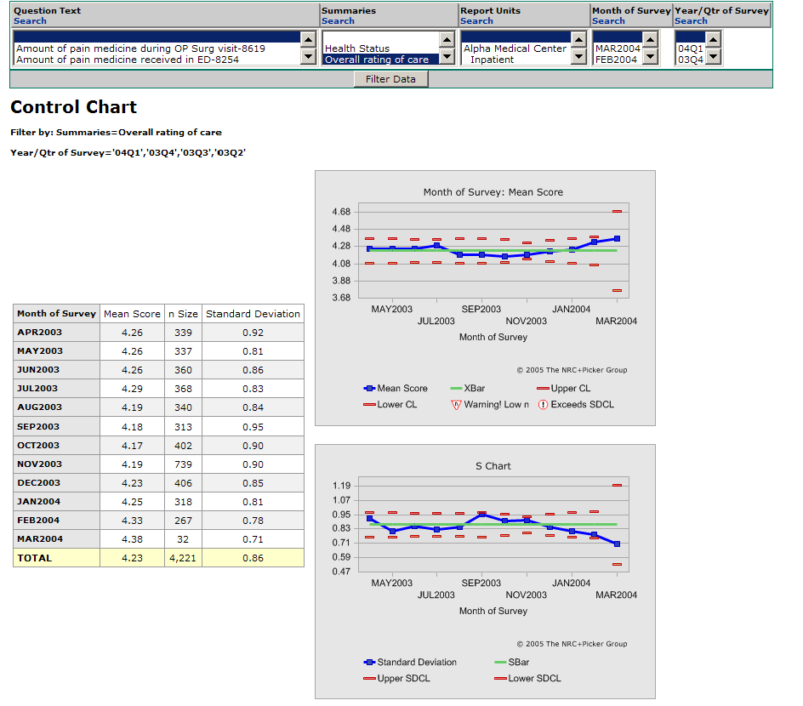
Legend for the Xbar Chart:
- Mean Score trend
- Upper/Lower limits
- Overall Mean (Xbar)
- Warning – n size < 25
- Exceeds SDCL- score exceeds control limits for standard deviation
Legend for the Sbar Chart:
- Mean Standard Deviation trend
- Upper/Lower limits
- Overall Standard Deviation mean
The Xbar – S Chart is composed of two types of data charts:

- S Chart (standard deviation control chart) is a control chart for the standard deviation values allows the user to determine if the variation, as measured by standard deviations, is stable for the observed mean scores. The interpretation of this chart is similar to the interpretation for the Xbar (mean score chart).
- Xbar (mean score chart) is a control chart that evaluates the stability within a process based upon observed mean scores.

NOTE: The Xbar control chart is meaningless unless the standard deviation control chart is in control.

The Xbar-S Chart is appropriate when the data being collected is continuous and there is more than one observation per subgroup. Subgroups refer to the grouping variable for observations such as, months, or quarters. When there are greater than 10 observations per subgroup than it is appropriate to use the Xbar-S Chart. Within eReports users will receive a low n-size (number of respondents) warning when the n-size for a subgroup is less than 25. Because this chart utilizes a control chart of the standard deviations a warning will appear for the mean score control chart whenever the data points on the S-Chart exceed the upper and lower control limits. This warning is identified as “Exceeds SDCL” and indicates that the associated standard deviation for the observed mean score exceeds either the upper or lower control limit. The following provides a brief description of the:

Specific Features of the SChart

- Mean Standard Deviation Trend Line (blue line) – this line provides a continuous trend that can be evaluated across a set time period.
- Upper and Lower Control Limits (dotted red lines) – the control limits provide parameters used to assess whether a process is stable and in control. When all data points are within the upper and lower control limits the process is stable.
- Sbar Trend Line (green line) – the Sbar line provides an overall mean for all observations (a grand mean) and plots this line to be contrasted with the mean standard deviation trend line.

Specific Features of the Xbar Chart

- Mean Score Trend Line (blue line) – this line provides a continuous trend that can be evaluated across a set time period.
- Upper and Lower Control Limits (dotted red lines) – the control limits provide parameters used to assess whether a process is stable and in control. When all data points are within the upper and lower control limits the process is stable.
- Xbar Trend Line (green line) – the Xbar line provides an overall mean for all observations (a grand mean) and plots this line to be contrasted with the mean score trend line.
- Warning Low n - this warning will appear on the Xbar chart and replace the observed data point whenever the n-size associated with a data point is less than 25. A further explanation of why an n-size of 25 is used to prompt this warning can be found in Module 3.
- Exceeds SDCL - this warning will appear on the Xbar chart and replace the observed data point whenever the standard deviation associated with a data point exceeds the upper or lower control limit within the Sbar Chart.

Additional Features and Information

Data Table – A data table that summarizes the data displayed in both charts will appear whenever these control charts are generated. This summary table will provide the subgroup variable (see the 1st column of the table). This will typically be the month of survey, or quarter of survey. The next three columns will provide the average mean score for the subgroup, the n-size for the subgroup, and the associated standard deviation for the mean score within the subgroup, in that order.

Filter Bar – Users can utilize the filter bar to change the question or dimension that is being viewed, the subgroup variable, and other features of the chart.

p - Control Chart Features

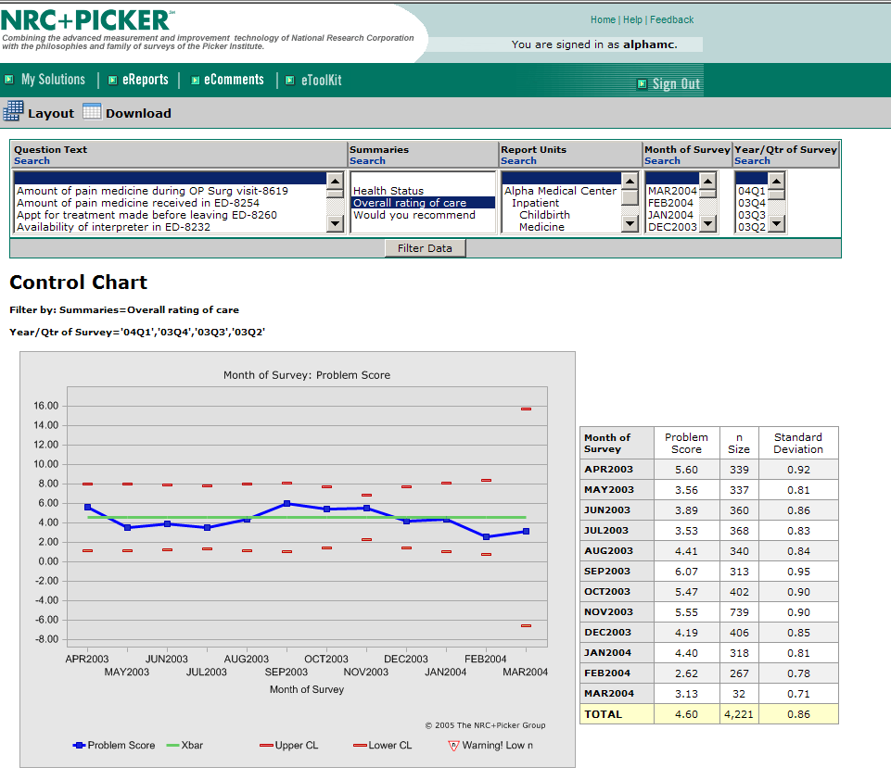

The p-chart is appropriate when assessing discrete or attribute data. This type of data can also be described as categorical. That is the data is defined by the category that is applied. When measuring patient experience the data can be defined as either a problem score or a positive score. Because a response can be identified as either positive or a problem response both occurrence and non-occurrences can be counted. When this is the case a p-chart is appropriate when the subgroups are not equal. Because the sample sizes that are observed across months or quarters tend to vary in size the p-chart is the control chart of choice for this type of data.

Specific Features of the p-Chart

- Mean Percent Response trend line (blue trend line) - this line provides a continuous trend that can be evaluated across a set time period. When trending percent response the trend line will either display problem scores or positive scores depending upon the default settings for your eReport site or specific selection made by the user in the Layout screen.
- Upper and Lower Control Limits (dotted red lines) – the control limits provide parameters used to assess whether a process is stable and in control. When all data points are within the upper and lower control limits the process is stable.
- Xbar Trend Line (green line) – the Xbar line provides an overall mean for all observations (a grand mean) and plots this line to be contrasted with the percent response score trend line.
- Warning Low n - this warning will appear on the p-chart and replace the observed data point whenever the n-size associated with a data point is less than 25. A further explanation of why an n-size of 25 is used to prompt this warning can be found in Module 3.

Additional Features and Information

Data Table – A data table that summarizes the data displayed in both charts will appear whenever the control chart is generated. This summary table will provide the subgroup variable (see the 1st column of the table). This will typically be the month of survey, or quarter of survey. The next three columns will provide the average percent response score for the subgroup (problem or positive), the n-size for the subgroup, and the associated standard deviation for the percent response score within the subgroup, in that order.

Filter Bar – Users can utilize the filter bar to change the question or dimension that is being viewed, the subgroup variable, and other features of the chart.

Module 2 – Accessing Control Charts

After completing Module 2 of the tutorial, you should feel comfortable:

- Logging on to your eReports or eToolkit account to access control charts.

Logging On

The first step in accessing eReports or eToolkit is to open your computer’s web browser (Microsoft Internet Explorer).
Once you are on the Internet, go to eReports or eToolkit by entering the following address in the browser address window:
Select My Solutions.
http://nrcpicker.com

You may also access both sites by selecting My Solutions.

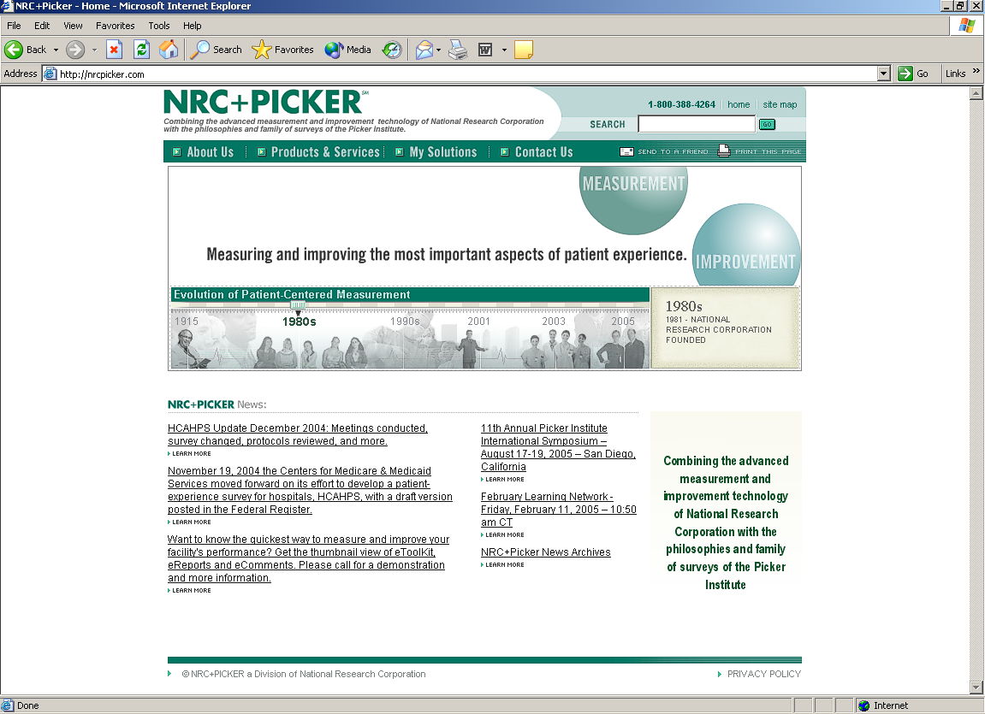
Enter the address here.

Creating Your “My Solutions” Bookmark

When the homepage opens, you may want to add the site to your web browser’s list of favorites or bookmarks. To do this, go to the tool bar at the top of the page and click on Favorites. Click on Add to Favorites. The next time you want to visit “My Solutions” simply go to Favorites on your Internet tool bar and scroll down until you find NRC+Picker - My Solutions.

Signing On To Your eReports

Click on the icon that says “eReports.”

You will be prompted for your facility user name and password. You should have received this from your NRC+Picker account representative. If you do not have a user name and password, please contact your Account Director.

Your username and password is:

eReports Username:
eReports Password:

Once you have entered, your user name and password select OK to enter your eReports or eToolKit website. NOTE: The passwords are case sensitive, meaning that Car is different from car.

Accessing eReports

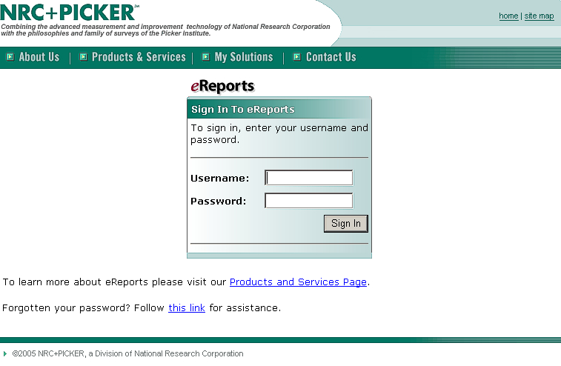
Enter username and password here

Accessing eToolKit
Enter username and password here
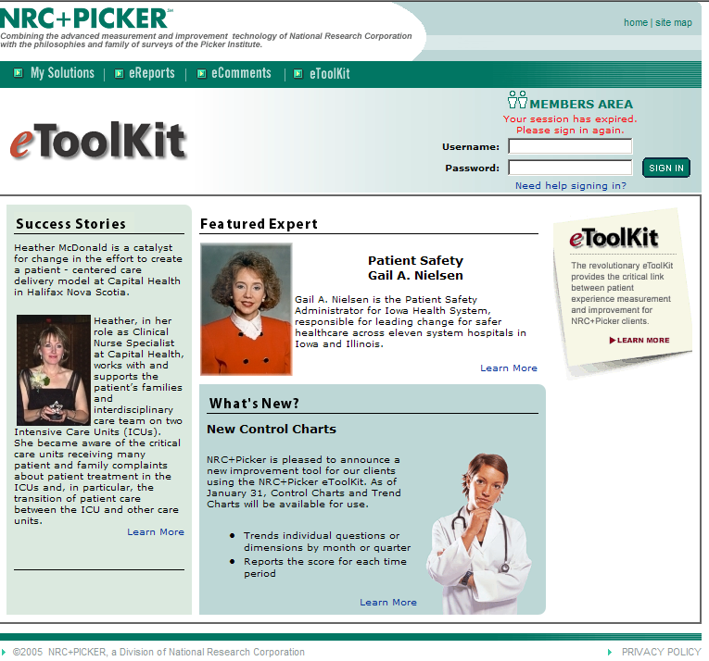

The eReports Menu

- The menu is a series of folders that contain all of your eReports information. The number of folders will vary.

To open a folder, click on the “+” sign. To access a one-click displayed under the eReports-heading click on the name of the report. The control charts can be accessed by selecting Custom Reports found underneath the Advanced Report heading.

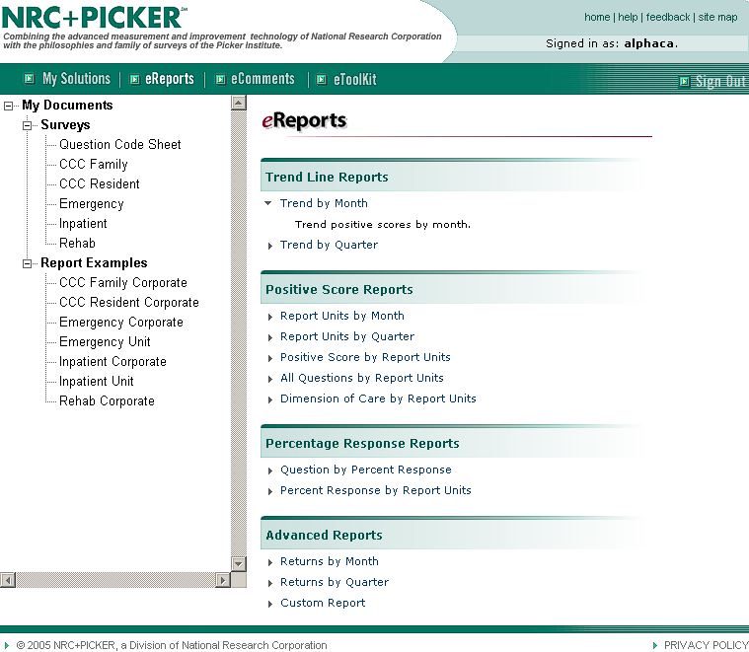
Open Custom Report to access the Control Chart Feature.
Open a report by clicking on the report name.

After selecting Custom Report, wait for the eReports report set up screen to open. The Report Setup screen allows the user to customize reports and select specific graphs to display. A control chart is one of the graphs that can be selected as a graph type.

Once control chart is selected as the type of graph, the user must determine the time increment that will be used to trend the data. Users will typically select Month of Survey but may also select Year/Qtr of Survey. This selection is made underneath the Dimensions column within the Down dialogue box. The user must also define the type of report to run. This is determined within the Statistics dialogue box and selecting the statistic type. The type of report is based upon whether mean score, problem score or positive score is selected.

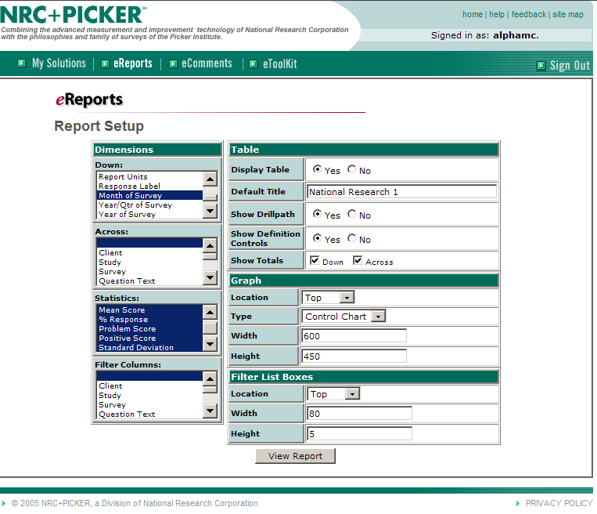
Select Control Chart as the Graph Type.
Select time increment.
Select the appropriate statistics.

eToolKit view My Data

- After logging onto eToolKit, users may access eToolKit data clicking view My Data. The eToolKit wizard will guide the user in selecting the proper date range and department or dimension to view by service area.

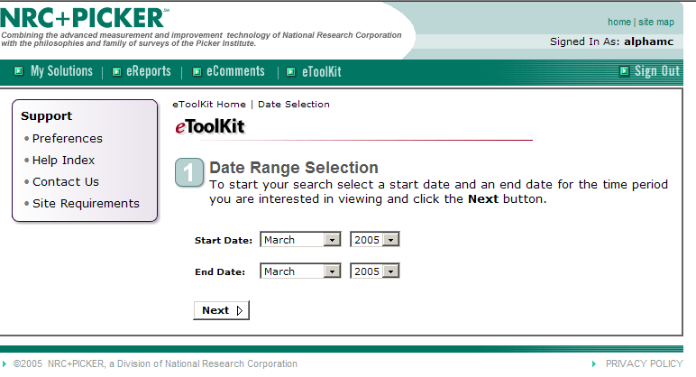
Select date range.
.Once the date range is selected the user will be prompted to select the appropriate service type.

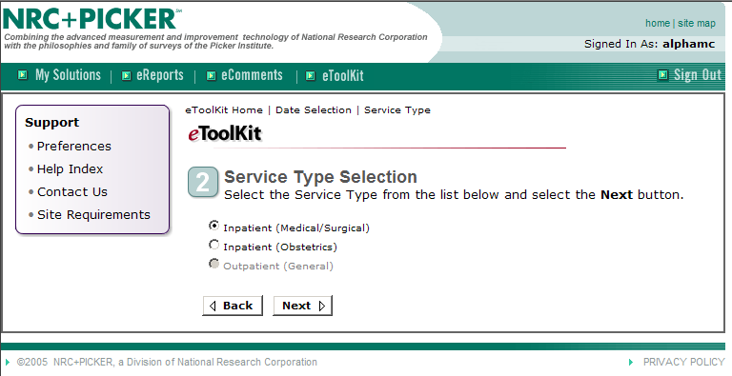
Select the service type.

Users will be prompted to select the desired service units once the service type is selected.

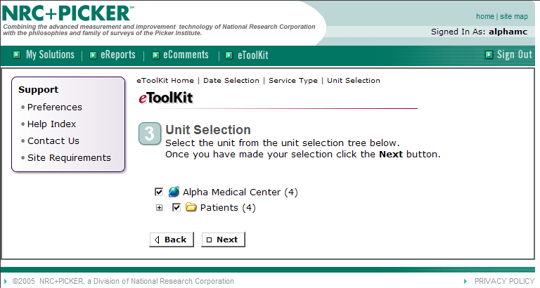
Select the service type.

The next step is to select a Department or Dimension view of the data.

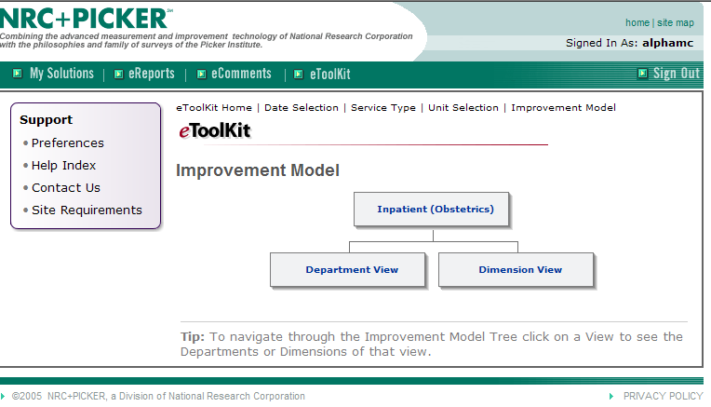
Select the appropriate view.

Once the user identifies the preferred view within eToolKit, the user will select specific dimensions or departments and then have the opportunity to drill down into individual question results.

Users may select the Control Chart View to display the results of any question.

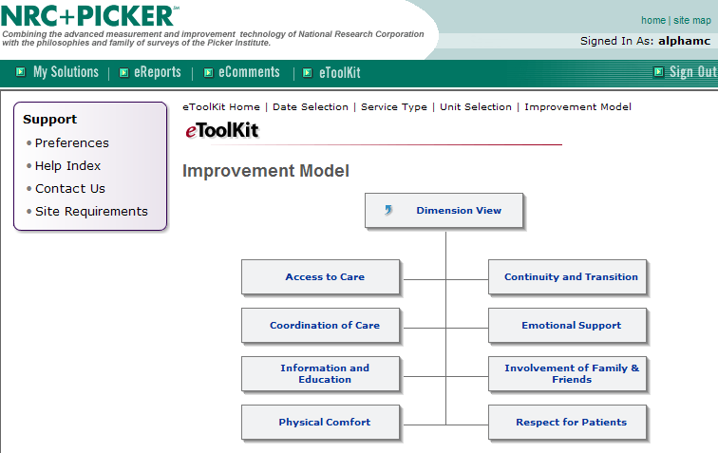
Select the department or dimension.

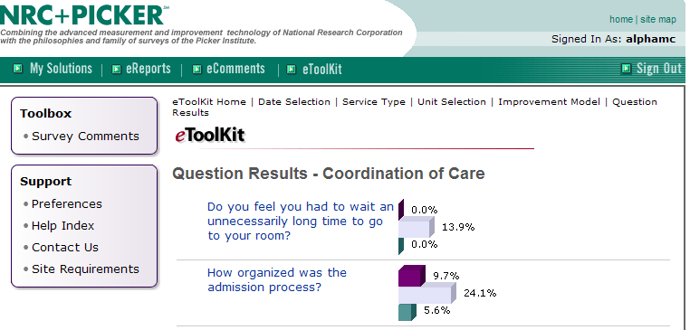
Drill into a specific question.

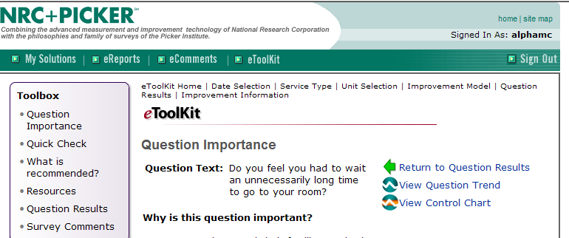
Select the appropriate view.

The link to View Control Chart date within eToolKit will link the user to the appropriate control chart based upon the question and the data that is accessed.

Module 3 – Basic SPC Techniques and Control Chart Formulas

After completing Module 3 of the tutorial you should feel comfortable:

- Understanding and utilizing basic SPC techniques to better understand control chart data
- Establish familiarity with the formulas used to calculate both the Xbar-S chart and the p-chart

Utilizing SPC Techniques to Understand Control Charts

The use of + 3 standard deviations is widely accepted as an industry standard within manufacturing. However, it may be necessary to also assess the nature of the problem or what is being measured when evaluating the proper control limits. The lower the number of standard deviations the less tolerant the control chart will be of special cause variation. Using 3 standard deviations is probably acceptable when assessing overall satisfaction or whether emotional support needs are met. However, when lives of patients are at stake, risk of secondary infection is a concern, or proper pain management of surgical patients is necessary than using 2 standard deviations might provide greater precision and early warning limits.

Assessing Special Cause Variation

The following methods can be used to assess the presence of special cause variation:

- One point outside the 3 standard deviation limits
- Two out of thee successive points beyond the 3 standard deviation limits
- Seven or more points in a row steadily increasing or decreasing indicate a trend if there are 21 or more date points
- Six or more points in a row steadily increasing or decreasing indicate a trend if there are fewer than 21 data points
- Fourteen successive points alternating up and down forming a saw tooth pattern (a cyclical pattern)
- A run of 8 points on either side of the center line
- An unusual or nonrandom pattern in the data

These interpretive techniques are among standard methods for understanding control charts. However, additional resources and methods can be found within statistical process control literature.

Important Reminder: When interpreting the Xbar-S Chart it is inappropriate to interpret the Xbar Chart (displays mean scores) if the S Chart (displays standard deviation scores) is not in control. The S chart indicates when the variation associated with the mean scores is stable and does not reflect special cause variation. When this indicator is not stable then the associated mean scores are not open to meaningful interpretation.

Formulas for Calculating Xbar-S Charts and p-Charts

Control limit for Percent score

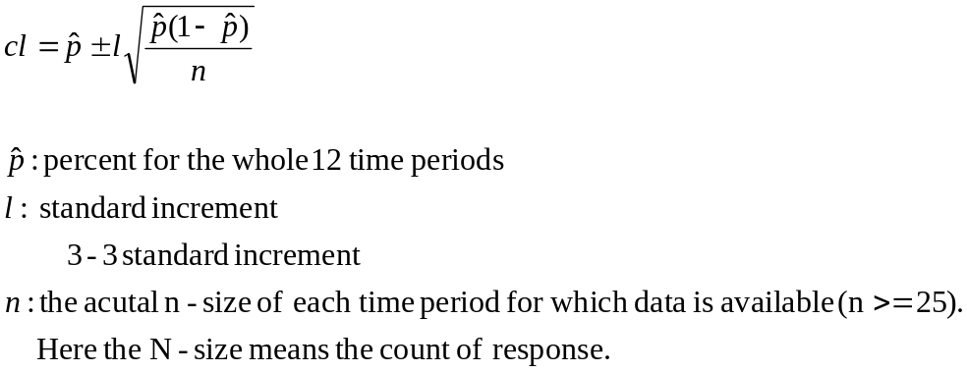
The control limit for percent has been adjusted so that the actual n for each sample set is used for calculating the control limit, not the average n-size across all sample sets. This is appropriate when the observed n-size within subgroups varies across subgroups.

Control limit for mean score

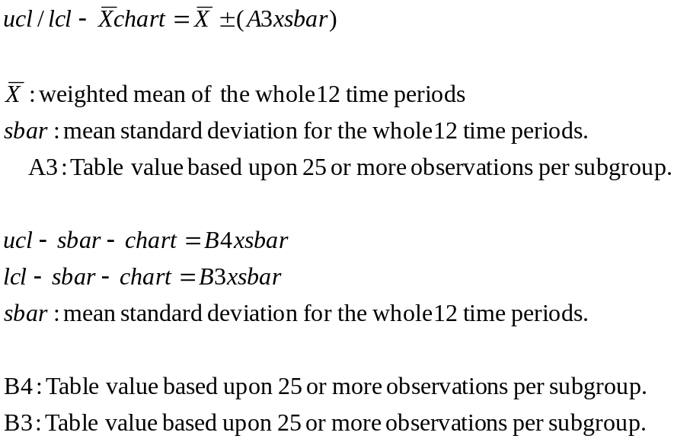

- Calculating upper/lower control limits for the X-Bar and s Charts requires a multiplier (constant) these constants are different for each control limit. However, when n-size is greater than 25 the formulas for calculating these constants are:

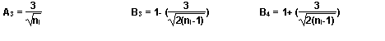
It is for this reason that within eReports whenever the n-size falls below 25 the user will see a warning indicating a low n-size.

Formulas for the XBar and s Charts:

Center Line

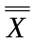 = ∑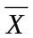/k

= ∑s/k

Where:
= mean score for each group/observation
s = standard deviation for each group/observation
k = the number of groups

Upper/Lower Control Limits
s-Bar Upper Control Limit: B₄ x
s-Bar Lower Control Limit: B₃ x

Where:
- = ∑s/k
  - s = standard deviation
  - k = number of groups
  - B₄ for n> 25 = 1+(3/ 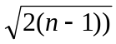

  - B₃ for n>25 = 1 - (3/

X-Bar Upper Control Limit: + (A₃ x )
X-Bar Lower Control Limit: - (A₃ x )
Where:
- sbar = ∑s/k
  - s = standard deviation
  - k = number of groups
- A₃ for n>25 = 3/